100 Thimbles in a Box
The Spirit and Beauty of Korean Handicrafts

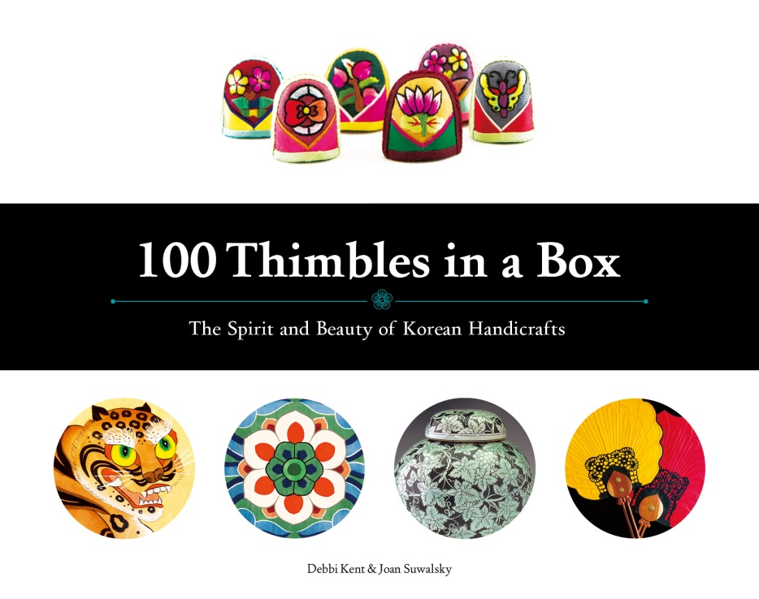
Authors: Debbi Kent, Joan Suwalsky | Softcover | 168 pages | Publisher: Seoul Selection
Publication Date: April 2014 | Dimensions: 11 x 8.6 x 0.5 inches | Price: USD 39.00

◆ The first time that all of Korea’s traditional crafts have been described in a
single English-language book
―A description of 44 crafts in seven categories, ranging from jogakbo (patchwork) to
kkotsalmun (temple doors)

◆ Written by two American women who adopted Korean children and
eventually became experts in the country’s handicrafts

◆ Contains more than 400 vivid pictures of Korean crafts

Inquiries about buying books
Hank Kim hankinseoul@gmail.com / Jinsook Jeong fran@seoulselection.com

Inquiries about press release
Hank Kim hankinseoul@gmail.com / Eugene Kim planner@seoulselection.com

Seoul Selection Bookshop (in Korea) +82-2-734-9565
Seoul Selection USA +1-949-509-6584
Website: www.seoulselection.com

The rich history of Korean traditional craftwork, honed over thousands of years

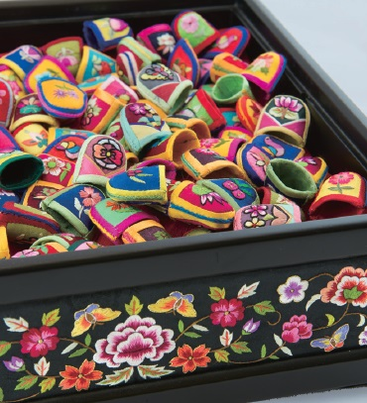
While Korean crafts have been an essential part of Korean life for centuries, the label of “traditional” has grown to tarnish some of their original luster. Outside of Korea, the country’s handicrafts are often overshadowed by those of China and Japan, preventing them from being recognized for their unique charm and cultural value. Frustrated with this widespread ignorance of Korean crafts, two American authors set out to write 100 Thimbles in a Box: The Spirit and Beauty of Korean Handicrafts, hoping that an English-language book on the topic would help bring some deserving global attention to Korea’s strong crafting history. The book’s title draws from a tradition dating back to the Joseon Dynasty in which a bride would present handmade thimbles to her husband’s female relatives to wish them good fortune and a long life. The stunning beauty of 44 of Korea’s traditional crafts—sorted into ceramics, fiber arts, paper, inlay, metal, wood, and painting—is presented in detail with over 400 pictures found in the book. While other publications have focused on one or two of these handicraft categories, this is the first English-language guide that brings these diverse genres together in a single volume.

Raising Korean adoptees spurs mothers to become experts in Korean handicrafts

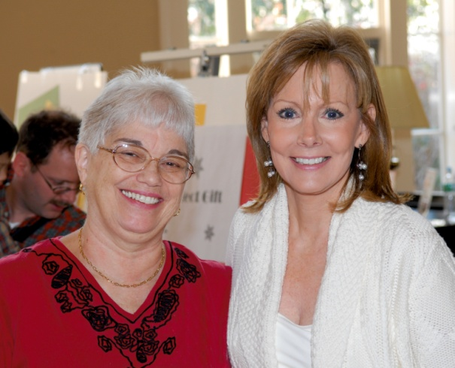
The story of how these two American women came to write a book about Korean handicrafts is a fascinating one. Debbi Kent and Joan Suwalsky both became interested in Korean culture while raising children they had adopted from Korea. Out of a desire to introduce their children to their Korean cultural roots, they would visit Korea once or twice each year and explore Namdaemun Market and Insa-dong to buy their children items related to Korean traditions. At first, they just picked out colorful clothing and norigae (ornamental knotwork) for their kids to wear, but they eventually fell in love with hwagak (ox horn decoration), najeonchilgi (mother-of-pearl inlay), and other Korean crafts. As the authors began to study the subject more intensively, their knowledge grew in both breadth and depth. In the end, each author’s drive to fully embrace their child’s birth culture is what inspired them to become experts in Korean handicrafts—a true labor of love.
Authors Joan Suwalsky (left) and Debbi Kent (right)

But the authors did not stop there. Instead, they decided to begin sharing their knowledge outside their families, organizing workshops and lectures about Korean crafts for parents and children at Korean culture camps and schools in the United States. They felt that not only was it important for their own children to learn about their birth culture, but that it could also be a valuable experience for other Korean adoptees and their families. Impressed by the combination of age-old wisdom and intricate technique, Americans appreciated the artistry of Korean craftwork, and the lectures and workshops have received a positive response. In recognition of the two women’s contributions to the embrace of Korean culture in America, the Korean Consulate in San Francisco awarded them a plaque of appreciation in 2012.
During their time spent giving workshops and lectures, Debbi and Joan sensed that Americans knew much less about Korean crafts than the ones associated with other Asian countries. Even those who had a genuine interest in the topic expressed that they had trouble finding appropriate books in English. It was this dearth that prompted the authors to publish a readable and entertaining book full of striking visual images that would captivate newcomers and connoisseurs alike.

Along with describing individual crafts, this book is a guide to Korean history and culture

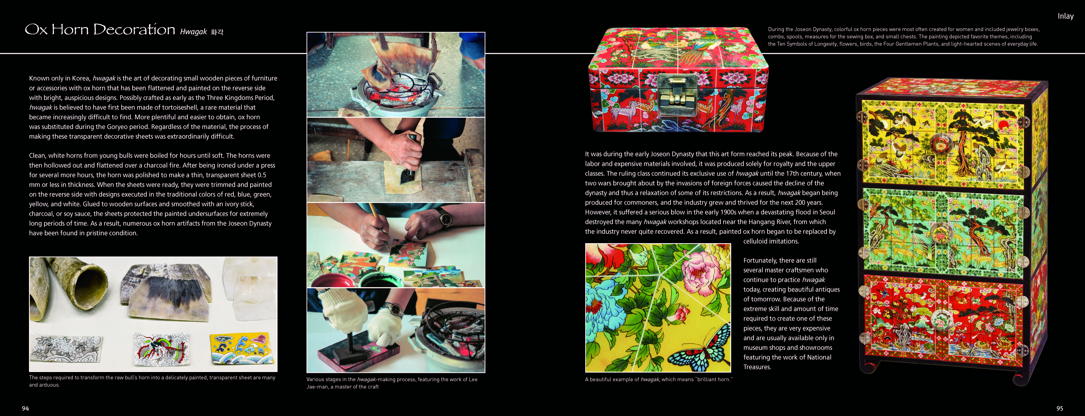

The book is divided into ten chapters. The first two chapters touch upon the historical, cultural, religious, and philosophical background of Korean handicrafts. Chapters 3 through 9 examine the seven categories of crafts, discussing their distinctive attributes, the story of

their development, and their manufacturing process. The final chapter looks at how traditional expertise and methods have been handed down from the past, how the original techniques are to be preserved, and how these crafts are being reinvented in the present.
In the second chapter, the authors provide a detailed explanation of various symbols that appear repeatedly in Korean handicrafts, as they believe that a grasp of these images is essential for understanding the lives and work of Koreans. These vigorous, charming symbols—which include familiar images such as the tiger, magpie, and lotus, as well as more philosophical concepts such as the sagunja (four gentlemen plants), sipjangsaeng (ten symbols of longevity), and obangsinjang (the spirit-generals of the five directions)—enable readers to understand the psychological and philosophical traditions that have shaped Korean culture for thousands of years. Chapter 10 tells the stories of distinguished craftsmen and artists who carry on the tradition by bringing these crafts to life today. The segment includes gold leaf artisan Kim Deok-hwan and his son Kim Gi-ho, whose unique approach has been handed down for five generations. Also highlighted are Chunghie Lee, a textile artist, and her daughter Jiyoung Chung, who applies the joomchi technique in making paper. Ms. Lee, who incorporates the beauty of bojagi (wrapping cloth) into her lectures at the Rhode Island School of Design in the United States, graciously wrote the book’s foreword.

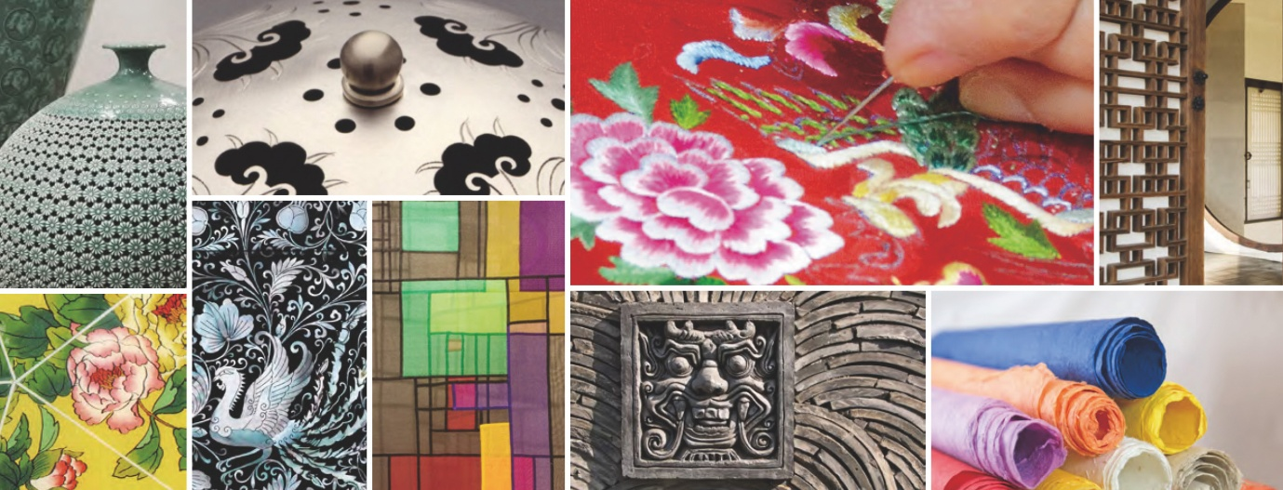

As Jai-Ok Shim, Executive Director of Fulbright Korea, said in her endorsement, this book does more than merely communicate information; thanks to its intricate design, it is a work of art in its own right. The design incorporates five bold colors that evoke Korea's traditional minhwa (folk paintings), an exotic motif that is designed to grab the attention of foreign readers. Of the more than 400 photos printed in the book, over half were taken by the authors during visits to various exhibitions, museums, and workshops. The rest of were provided by 20-plus museums and associated organizations, including the National Museum of Korea, the National Palace Museum of Korea, the Jordan Schnitzer Museum of Art, and the Leeum, Samsung Museum of Art.
One cannot help but be moved by the passion and dedication exhibited by the authors, who spent about twenty years gathering material, writing the text, and taking the photos. These women are more than simply foreigners enchanted with an unfamiliar culture; they are mothers crafting something with love for their children to cherish.

About the Authors

Debbi Kent and her husband Bill have three children—their son Justin and their two daughters adopted from Korea, Whitney and Melanie. Debbi’s professional career has included work as a writer, editor, public speaker, marketing representative, and designer. In her free time, Debbi enjoys travel, photography, interior design, and fabric arts.

Joan Suwalsky and her husband Al adopted two Korean-born children, April and Ted. Joan is a developmental psychologist by profession and studies child growth and family functioning, including in adoptive families, at the National Institute of Child Health and Human Development in Bethesda, MD. In her spare time, she is an avid potter and gardener.

Endorsements

100 Thimbles in a Box is a charming introduction to a great range of Korean handicrafts, from the tiny thimbles—an old-fashioned woman’s intimate companion—to the once ubiquitous lattice and paper doors of traditional Korean homes. The authors have tacked down popular accounts of each handicraft, as contemporary Koreans now understand and appreciate them, and abundant photographs that convey the feel and appeal of ceramics, stone, paintings, masks, clothing, and furniture. Spending time in these pages is an enticement to visit Korea for a first-hand encounter with these things themselves.
— Dr. Laurel Kendall
Division Chair and Curator of Asian Ethnology, American Museum of Natural History

While many theorists and art historians have tried to pinpoint the beauty and essence of Korean craft, its familiarity and universality have kept it from being fully understood and properly appreciated until this book. Ideal for the general reader, 100 Thimbles in a Box covers various themes and media in Korean art. As they explore the hidden symbolism and unique uses of Korean handicraft, the two authors trace connections between Korea’s past and present. Offering abundant visual material, this book illustrates how Koreans have enjoyed art and culture in every moment of their lives.

— Hyonjeong Kim Han
Associate Curator for Korean Art, Asian Art Museum of San Francisco

As Korea continues to forge ahead in the era of globalization, 100 Thimbles in a Box provides a timely and necessary reminder of the persistence and beauty of traditional Korea. This thoroughly researched and elegantly photographed book is more than a source of knowledge; it is itself a piece of art. Debbi Kent and Joan Suwalsky have seamlessly blended culture, art, and history to offer readers an extensive overview of Korean handicraft, tradition, and identity.

— Jai-Ok Shim
Executive Director, Fulbright Korea

100 Thimbles in a Box will be treasured by everyone who loves traditional Korean culture and art. For adoptees and adoptive parents, however, it will also serve to nurture and support individual and family identity and pride. This beautiful volume will keep Korea close to all of us who love Korea, whether we are joined to it by birth, adoption, or simple admiration for its rich cultural heritage.

— Margie Perscheid
President, Korean Focus

This beautiful book is a perfect introduction to Korean handicraft traditions for English-speaking audiences. Visually stunning, it places traditional art forms in the philosophical and religious contexts in which they have grown over the past 5,000 years, describing how they were (and still are) made, and how they were central to the lives of the Korean people. It offers a clear explanation of the symbols that permeate handicrafts, their origins, and their functions: to bestow blessings and protect from harm. In a final chapter, the status of handicrafts in modern Korea is explored with explanations of how they are being preserved through the efforts of expert artisans and reborn in the beautiful work of modern Korean artists. This fascinating book will whet the appetite of any reader to learn more about the vibrant, engaging folk art that has colored the everyday lives of Koreans for generations.

— Byung Goo Choi
Director, Korean Cultural Center in Washington, D.C.

Discovering the beauty hidden around us in our everyday lives—pausing to appreciate, for example, the humble glory of a wildflower—that brings warmth to our hearts. There are not many books that describe, as 100 Thimbles in a Box does, the familiar grace and charm of Korean handicraft in terms of its symbolism and the various techniques involved in producing it. I believe that this book will help many individuals come not only to understand Korea, but also to love it.

— Kim Yeonsoo
Former Director, Research Division of Artistic Heritage,
National Research Institute of Cultural Heritage in Korea

Contents

Foreword
Preface

Chapter 1 Introduction
Handicrafts: Mirrors of the Soul
Philosophical, Spiritual, and Religious Traditions in Korea
Historical Timeline of the Korean Peninsula

Chapter 2 Symbolism in Korean Handicrafts
The Origins of Korean Symbols
Individual Symbols
Groups of Symbols

Chapter 3 Ceramics & Clay
Celadon
Stoneware
White Porcelain
Earthenware Pots
Roof Tiles
Walls and Chimneys

Chapter 4 Fiber Arts
Thimbles
Embroidery
Ornamental Knotwork
Gold Leaf Imprinting
Wrapping Cloths
Korean Patchwork
Traditional Costume
Accessories for Hanbok

Chapter 5 Paper
Handmade Paper
Fans
Kites
Lanterns

Chapter 6 Inlay
Metal Inlay
Mother-of-Pearl Inlay
Ox Horn Decoration

Chapter 7 Metal
Furniture Hardware
Bells
Royal Gold

Chapter 8 Wood
Masks
Drums
Spirit Poles
Totem Poles
Stamps and Molds
Wedding Geese
Funerary Figures
Temple Doors
Furniture
Windows and Doors

Chapter 9 Painting
Folk Paintings
Paintings of Ten Longevity Symbols
Paintings of Sun, Moon, and Five Peaks
Character Paintings
Scholar’s Study Paintings
Folding Screens
Genre Paintings
Literati Paintings
Documentary Paintings
Architectural Painting

Chapter 10 Handicrafts in Korea Today
A Culture in Crisis
Living National Treasures
Five Generations of Superior Craftmanship
Traditional Themes Coming of Age
Reaching to the Past to Create the Future
Pushing the Envelope
The Tradition Lives On

Acknowledgements
References
Index

